Creating a Program Logic Model Framework
Clarifying Program Theory & Planning Logic Models

Complete the worksheet with information about your project, then create a Theory of Change Model
Creating a Theory of Change Model:
Discuss:
- What do you want to “get” / Results?

- What do you need to “do” / Strategies?

- What are your assumptions?

Draw your Theory of Change Model:

Creating a Program Logic Model:
IMPORTANT: Before you develop your Program Logic Model, be sure you have completed your Theory of Change Model. Use your TOC to guide the development of your PLM.
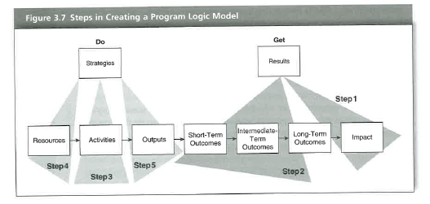
Image from Knowlton & Phillips (2013), p. 44

Step 4 | Step 3 | Step 5 | Step 2 | Step 1
Resources | Activities | Outputs | Outcomes | Impact
In order to accomplish our set of activities we need the following: (consider also what Standards of Practice might inform your work – NSEE, Forum, NAFSA, ACPA, CAS) | In order to address our problem or need, we will conduct the following activities: (use literature & good practices to inform concrete activities) | We expect that once completed or underway, the activities will produce the following evidence: Qualify, Quantify and Describe your activities | We expect that if completed, these activities will lead to the following changes:  Short-term?  Intermediate-term?  Long-term? (Define timelines appropriate to your project scope) | We expect that if we are successful in achieving our plans this will lead to the overall lasting change (Consider how this relates to your TOC Results)

Draw your Program Logic Model

